**Sapphire Booster Club – March 19, 2024 @ 7:15pm**

**Attendees can be found in the meeting folder.**

1. **VOTES**
   1. Meeting Minutes
      1. Nikki motioned we accept February meeting minutes as posted to our website for the membership; Megan seconded
      2. Outcome: Passed unanimously.
2. **President’s Update – Nikki**
   1. SBJI – Profit = $12,720. This is $5,480 less than we had estimated
      1. Bulk of this difference was from event location charges (+$2,000), increase in Judge’s fees (+$2,500), Awards (+$3,667 – this committee did fundraise an extra $1500 to help offset costs)
      2. Offset by higher than estimated income, driven mainly by admissions (-$2775)
      3. Courtney would like to emphasize “We did great for our first-year hosting in several years! Unlike State, that we’ve hosted most recently, attendance (gymnast registrations) isn’t guaranteed and we would expect it to grow from here!” She also wanted us to pass along that “She’s so proud of how our families showed up for the girls and how well everyone worked together.”
      4. If anyone would like to see budget vs actual spreadsheet, we can certainly provide, just let us know!
      5. Share feedback from Coaches/other Gyms…along with the 2.22.24 meeting minute feedback.
3. **Treasurer’s Update - Megan and Chris**
   1. Show meet fees collected vs expenses paid thus far. These docs can also be shared if anyone would like to see.
   2. DP

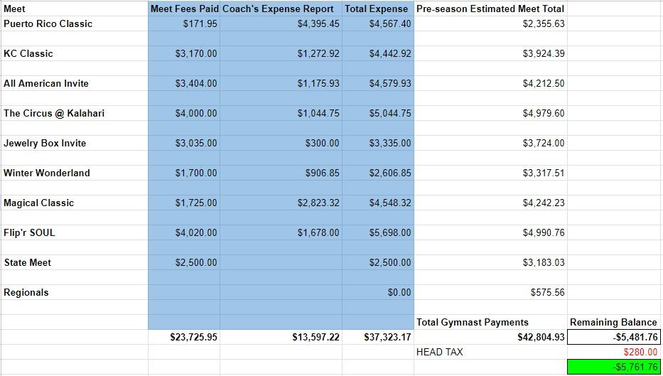

c. Xcel

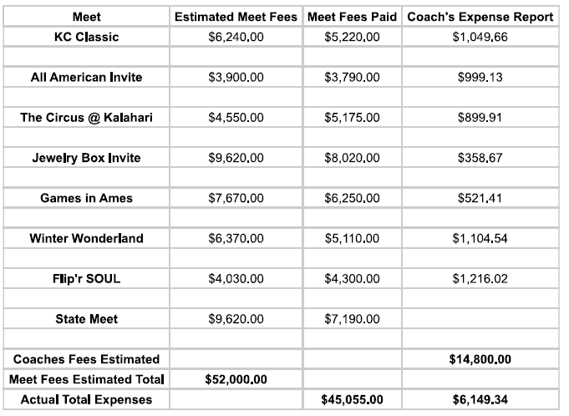

1. **Coaches Update**
   1. Xcel parents - please touch base with Alisha regarding your plans for next year if you haven’t already done so.
   2. Dev parents - please send Alisha report cards for acknowledgement during the year end banquet for your student athlete.
   3. Backpack update: The gym will be getting a full refund. Once received, the gym will place a credit on your account that will be used towards the next month's tuition.
2. **REMINDERS**
   1. Looking for DP and Xcel photos for end of year banquet slide show – email sent
3. **Meet Hosting**
4. Work is underway to put together Xcel State bid.
5. SBJI – We will be moving the meet to the RecPlex in WDM, Jan 31-Feb 2, 2025!
6. **SBC Committees**
   1. End of Year Banquet - Xcel committee and a DP committee.
      1. April 13th American Legion in Urbandale, 4 sessions in single day, save the date posted on FB
7. **Team Fundraising**
   1. Pump it Up – what Mon – Thurs works? 5:30-7:30pm.
      1. Lloyd will reserve the 16th, 23rd, 30th and we’ll work to narrow down a day.
      2. Min 40/Max 80 kids. $20/kid (Pump it up will take $5). Would need to market to non-gym members through social media. Need to have a way for tickets to be purchased through the link (website: event bright). They will staff the event but we would have to have a few volunteers there. Options for food as well. Nikki (& social committee) will take a look at next steps and work with Lloyd.
   2. Raygun – Lloyd and Nichole have been in talks with Raygun about developing gymnastics shirt that could be sold to broad market. Waiting for designs.
   3. **Other ideas from Feb Meeting**
      1. Group fundraising ideas:
         1. Drake Relays
         2. Concessions at Principal Park – must work 8 games (5 hour shifts) over the course of the season with 9% on weekends games, 15% on weekday games, 90% tips
            1. Clean up volunteers could include younger girls
            2. Do we know how many people we need for each shifts?
         3. Krist Kindl Market downtown
         4. Wells Fargo Arena?
         5. We have a listing of places where we could possibly do a spirit night if anyone is interested in driving this type of fundraising activity.
      2. Individual fundraising ideas: Butter braids
   4. **Active Team fundraisers**
      1. Amazon affiliate
      2. Yard signs - sold approx. 54/98 needed to break even
         1. $10 Additional donation received during Sign sales
         2. We have provided a couple of signs for gymnasts that have been injured – please let us know if you hear of any injuries, we don’t want to miss anyone!!
         3. What is plan to try to sell again?
            1. In the pro shop
            2. Going to try to sell during spring fling
      3. Trivia Night - Approx $350 profit
      4. Ear rings - $230 raised
      5. Raise Right (Gym sale – benefits group)
      6. SJBI
   5. **Active Individual fundraisers**
      1. Raise Right
      2. Flip Give – can still utilize this year!
      3. Committee would like a volunteer to research individual fundraiser ideas.
      4. Can participate in individual fundraising as much/as little as works for you.
   6. **Fundraising Goals**
      1. Important - Transparency
      2. Priorities for fundraising this season
         1. To reimburse expenses solely paid by DP this year - $3250
         2. To ensure we can host meet this year & next year - estimated $35k annual
            1. Meet Fees from Gyms coming in - approx. $33k so far
         3. To offset 24/25 meet expenses - the limit does not exist
8. **DP State Accomplishments!**
9. **Q&A/Notes**
   1. University of Iowa is doing an camp in June (6/21-6/23 or 6/25-6/27), can we coordinate having a group trip to this?? The social committee will take a look at this.
   2. Annual meeting will be held in May:
   3. If you’d like to volunteer for a board position, this will be the time to let your desire be known!
      1. Chris and Beth will be moving on from our positions next year.
   4. Review board by laws: (Copies of by laws printed out)
      1. Should we charge by laws to allow Sapphire employees to be on board.
      2. Should we have a term limit for board members?

**Next Meeting – April 18, 2024 @ 7:15pm in Preschool Lobby.**